.NET for AmiBroker ReadMe

Contents
System requirements of .NET for AmiBroker (x86) 2
System requirements of .NET for AmiBroker (x64) 2
Installing .NET for AmiBroker 2
Updating .NET for AmiBroker 3
Temporarily disabling .NET for AmiBroker 3
Removing .NET for AmiBroker 3
Troubleshooting .NET for AmiBroker and .NET plug-ins 3
Known Issues 3
Support 3

System requirements of .NET for AmiBroker (x86)
Requirements for Free, Standard and Developer editions:
- Windows XP/Vista/7/8 (32/64 bit, latest Service Pack)
- .NET Framework 4.0 (latest Service Pack)
- AmiBroker 6.2X (32 bit)
Requirements for Developer Edition only:
- All samples and code sources are provided as Microsoft Visual Studio 2012 projects. Microsoft Visual Studio can be used to change and build these projects. It is also possible to use the free Microsoft Visual C# Express and Microsoft Visual Basic Express to view and edit and build the samples and to create new plug-ins. However, Visual Studio Express does not allow debugging .NET plug-ins.

System requirements of .NET for AmiBroker (x64)
Requirements for Free, Standard and Developer editions:
- Windows XP/Vista/7/8 (64 bit, latest Service Pack)
- .NET Framework 4.0 (latest Service Pack)
- AmiBroker 6.2X x64 (64 bit)
Requirements for Developer Edition only:
- All samples and code sources are provided as Microsoft Visual Studio 2012 projects. Microsoft Visual Studio can be used to change and build these projects. It is also possible to use the free Microsoft Visual C# Express and Microsoft Visual Basic Express to view and edit and build the samples and to create new plug-ins. However, Visual Studio Express does not allow debugging .NET plug-ins.

Installing .NET for AmiBroker
- Login in to your computer with administrative privileges.
- Start the setup utility after downloading and extracting the deployment package.
- During installation you are requested for AmiBroker’s installation path. If you have installed AmiBroker into its default path, accept the provided default value. Please, note, that 32 bit and 64 bit versions must be installed into the folder of respective AmiBroker versions.
- Select the software edition and the components to install.
- Select the Start menu folder to place menu items.
- Finish installation.
- At the first startup of AmiBroker the following window will appear:
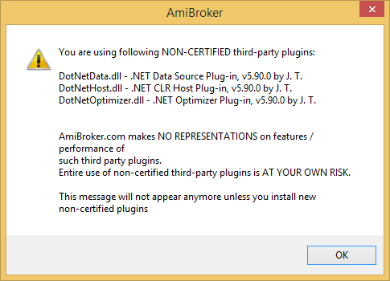

Changing .NET for AmiBroker edition or version
If the deployed .NET for AmiBroker edition or version needs to be changed, the current version must be uninstalled (Control Panel - Add or Remove Programs applet) and then the new edition or version should be installed. By uninstalling the .NET for AmiBroker only the items deployed by the setup utility are removed. All other files (including rebuilt samples) remain unchanged.

Temporarily disabling .NET for AmiBroker
If you are in doubt of .NET for AmiBroker causing some issues, you may temporarily disable the product by stopping all instances of AmiBroker and removing DotNetHost.dll from AmiBroker’s Plugins folder (renaming may not work as expected!).

Removing .NET for AmiBroker
You can remove the software package from the Control Panel - Add or Remove Programs applet. Only the items deployed by the setup utility are removed. All other files remain unchanged.

Troubleshooting .NET for AmiBroker and .NET plug-ins
Diag and License Utility (dl.exe) can detect setup and configuration issues. It can be started from the Start menu or from .NET for AmiBroker folder.
.NET for AmiBroker writes messages to its instance log file. A new instance log file is created at each AmiBroker process startup in the Logs folder.Instance log entries can help to solve issues with .NET for AmiBroker and .NET plug-ins under development.

Known Issues
- If plug-ins are unloaded by using the AmiBroker menu (Tools-Plug-Ins…-Unload), all plug-ins (including the .NET CLR host plug-in) are stopped and unloaded from the memory. Once .NET runtime is stopped it cannot be restarted. All subsequent requests of reloading the plug-ins will load all plug-ins including .NET CLR host. However starting up the .NET CLR runtime will fail and .NET plug-ins are not reloaded. To reload .NET plug-ins AmiBroker must be restarted.
- .NET plug-ins do not appear in AmiBroker’s plug-in window by design because .NET plug-in dlls are not loaded directly by AmiBroker. Only DotNetHost, DotNetData and DotNetOptimizer native plug-ins appear in this window. Loaded .NET plug-ins and .NET method mapping can be printed to AmiBroker’s Trace window by Admin.afl

Support
In case of having any technical difficulties, please, check the .NET for AmiBroker forum for answer first.
To request for technical support, please, send a mail to mailto:dotnetforab@gmail.com. Your mail should have detailed description of the issue and a request data file. You can create a support request data file by running dl.exe in .NET for AmiBroker folder.
.NET for AmiBroker is a 3rd party product NOT ENDORSED NOR SUPPORTED by AmiBroker.com in any way.

